T +1 (603) 438 6360 (North America)
T +44 (0) 161 711 0564 (EMEA)
T +61 (08) 8212 5188 (APAC)
E sales@cammsgroup.com
W www.cammsgroup.com

Camms.Insights Reporting
Capability Reference Guide &
Report Development Best Practices

PRIVILEGED AND CONFIDENTIAL

Prepared by Camms
22 June 2021
Overview
Camms.Insights is an ad-hoc report builder which allows business users to create reports within minutes and easily share them with others.
This document outlines the level of complexity that must be considered when recommending Camms.Insights to a business user as well as overall report development best practices.

Camms. Insights Reporting Capability Reference Guide
Most business users will only be able to build Low complexity reports themselves and will require Camms assistance to build Medium complexity reports. Please also keep in mind that even a Low complexity Insights report may not be feasible for certain organisations with very large data loads. For example, a very low complexity Incident report may be impractical for an organisation with 1000+ Incidents in their database as it will not load or export within industry expected standards. As a workaround for this within Insights, custom datasets would have to be built by Camms.

- Low Complexity Reports –

Often Built by Business Users
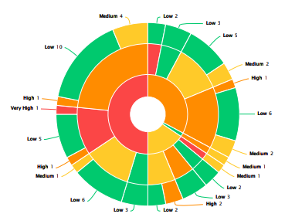
From an Insights perspective, these reports will ideally contain 1 to 3 standard data sets (could differ from product to product as well as the overall data load). Some of the other attributes of these reports are:

- Basic tabular layout with simple grids and charts
- Utilizing 2 - 3 data sources with preset relationships.
- Use of a basic standard header/footer.
- Simple filtering and basic calculated expressions.
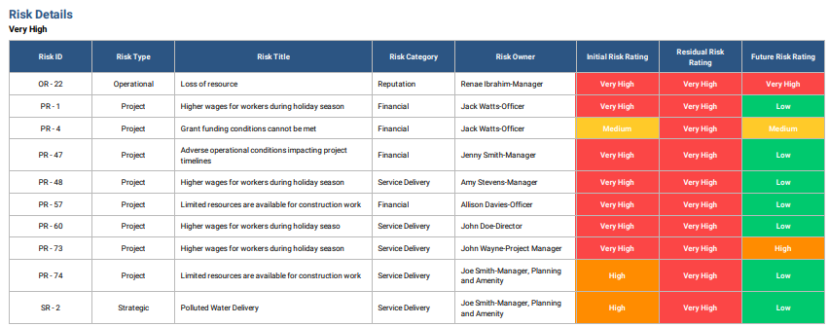

Refer our Camms Reporting Library for sample reports which are considered to be low complex reports:
- https://cammsgroup.freshdesk.com/support/solutions/articles/43000572401-obligation-register-insights
- https://cammsgroup.freshdesk.com/support/solutions/articles/43000571088-audit-action-report-with-ageing-insights
- https://cammsgroup.freshdesk.com/support/solutions/articles/43000583082-risk-assessment-report-insights

- Medium Complexity Reports –

Built by Advanced Users or Camms
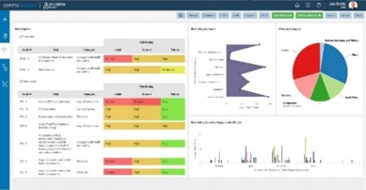
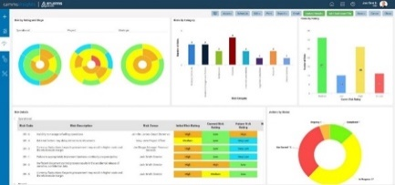
From an Insights perspective, the attributes of a Medium complexity report are as below:

- Combination of multiple data sources using complex joins to draw data from different areas into a single report.
- Ability to use HTML/CSS to enhance your report and achieve non-standard report layouts.
- Incorporating advanced calculated expressions and filtering
- Use of custom datasets designed by Camms especially for your organisation.
- Use of sub reports.

Refer our Camms Reporting Library for reports which are considered moderately complex.
- https://cammsgroup.freshdesk.com/support/solutions/articles/43000594011-project-charter-report-insights
- https://cammsgroup.freshdesk.com/support/solutions/articles/43000561732-project-on-a-page-insights
- https://cammsgroup.freshdesk.com/support/solutions/articles/43000539894-strategic-plan-insights
- https://cammsgroup.freshdesk.com/support/solutions/articles/43000539475-operational-risk-detailed-report-insights
- https://cammsgroup.freshdesk.com/support/solutions/articles/43000570839-incident-update-report-insights
- https://cammsgroup.freshdesk.com/support/solutions/articles/43000594792-audit-details-report-insights

- High Complexity Reports
- As an overarching rule of thumb, please keep in mind that Camms.Insights is recommended for Low to Medium complexity reports only with the understanding that many Medium complexity reports would require custom datasets.
- High complexity reports from an Insights perspective are those that require many nested sub reports and/or datasets to achieve the desired output. Furthermore, reports which require visualisations such as Heatmaps, Gantt charts and Progress bars which are not supported by Camms.Insights are also considered High complexity.
- Therefore, High complexity reports should always be developed through SSRS. Furthermore, for professional looking, high quality reports which would primarily need to be printed for distribution, SQL Server Reporting Services (SSRS) would always be recommended above Insights.

Camms Insights - Report Development Best Practices

This section provides guidance that enables report developers and administrators to create and maintain performance optimised reporting solutions using Camms.Insights.
- Usage of datasets should be minimal
- Users should be mindful regarding the number of datasets used when creating reporting outputs, and try to create reports using the minimum number of datasets possible. Wherever possible, make effective use of the fact that some data fields appear in more than one dataset. Loading an unnecessary/unused dataset to a report results in additional data load, which directly impacts the performance of the report.
E.g. In some cases, you may not need both the Project Register and Project Details datasets as they have several fields in common. Using only one of the two datasets based on your requirement will be effective.
- Make sure the dataset Joins are defined in the most efficient manner.
- If it is required to join more than 5 datasets for a single report, please reach out to the Camms Reporting Hub team to ensure that the joins themselves are efficient and in the best order (top to bottom). They will further evaluate and advise whether your reporting requirement can be better served with a single custom dataset in some cases.
- Usage of calculated fields.
- Similar to datasets, users should be mindful when using Calculated Fields in the reports as well. Users should not use more calculated fields than what is actually needed. Keep in mind that each unnecessary/unused calculated field in the report results in an additional data load which directly impacts performance.

E.g. If you have 10 calculated fields in the report but are only using 1-2 for display or filters, delete all others.

- If it is required to;
  - write very lengthy/complex SQL statements in your calculated fields and/or
  - need more than 10 calculated fields for a single report
please reach out to the Camms Reporting Hub team to ensure that they are all written efficiently. The team will further evaluate and advise whether your reporting requirement can be better served with a single custom dataset (with built in calculated fields) in some cases.
- Create calculated fields only when actually required. Insights offers built-in functionalities to accommodate most of the customizations. If you are unsure if a built-in functionality is available or not, please reach out to the Camms Reporting Hub team for assistance.

E.g. If you need to specify alternative text for data retrieved by a specific field, use the built in Alternative text functionality (Field Properties > Data Formatting > Alternative Text) (Figure 1) and do not create a calculated field as shown below (Figure 2).
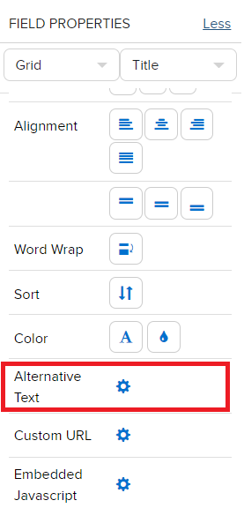
Figure 1 - Alternative Text function under Field Properties
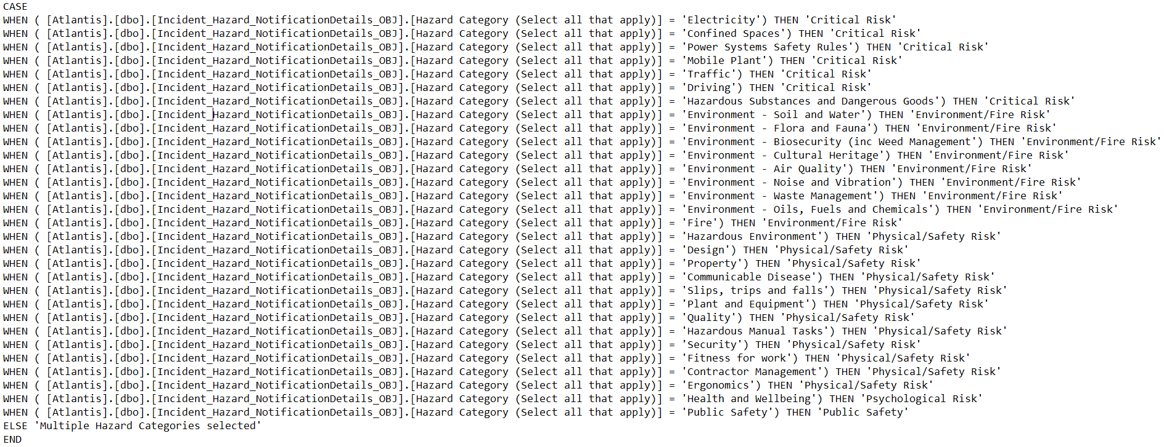
Figure 2 - Inefficient Usage of Calculated Fields
- Usage of images
- Similar to datasets and calculated fields, do not use more images than what is actually required. In addition to your logo, if it is required to add more than 2-3 conditional icons or images, keep in mind that they can slow your report down.
- Usage of schedules
- It is ideal if report schedules can be defined for delivery outside business hours and do not schedule multiple reports at the same time. Try exporting your report and gauge how long it normally takes to generate the output, and use that as a guideline to keep healthy gaps between schedules.

E.g. If your report takes 5 mins to export and you schedule it for 8pm, schedule your next report at least at 8.05pm (this allows sufficient time for your first report schedule to run without impacting the second).
- Usage of embedded reports
- Embedding a Grid report part within a Grid report (as show below in Figure 3), can slow it down unnecessarily. Where possible, make the main report a Design Form and embed Grid parts, Chart parts or other Design Form parts as sub reports within it which is far more efficient.
- If it is required to embed reports more than one level deep (a sub report embedded within a sub report, which is embedded in the main report), please reach out to the Camms Reporting Hub team to ensure that the overall report is designed for maximum efficiency. The team will further evaluate and advise whether your reporting requirement can be better served via custom datasets or via SQL Server Reporting Services (SSRS) in some cases.
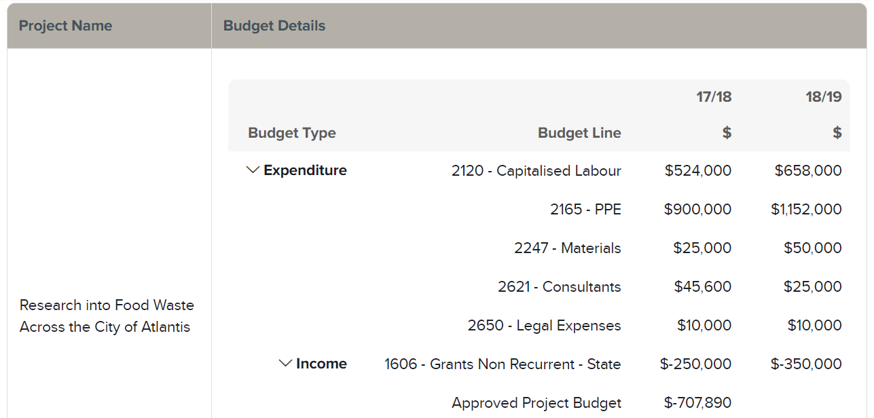
Figure 3 - Embedding a Grid Report Part within another Grid Report Part
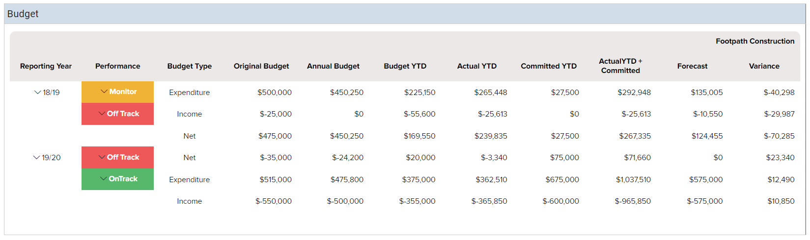
Figure 4 - Embedding a Grid Report Part within a Design Form Report Part

As a general rule of thumb, contact reportinghub@cammsgroup.com for assistance when a report that you have built meets any of the following criteria;
- Taking a lot of time to load and export
- Frequently delayed delivery even though you have no other schedules running at the same time

